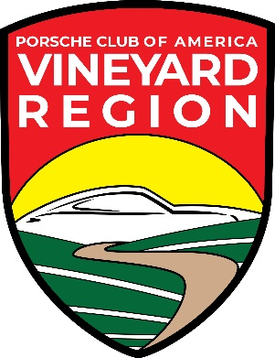
PORSCHE CLUB OF AMERICA,
VINEYARD REGION
Event Sponsor Form
Pcavineyardregion.com

Use this form to submit your proposed Event for PCA Vinyard Region.
Provide description of your event (Tech Session, Coffee Meet, Lunch Event, etc.)

Date or Dates:
Establishment:
Address:
Authorized by: Signature:
Title: Member or Non-Member:

Please return this form to drs928@hotmail.com or,
Along with payment to: PCA Vinyard Region, 27555 Ynez Rd, Ste 110, Temecula, 92591
This will be viewable on our website pcavineyardregion.com under Events.
Contact: D R Snyder, 619.757.6767, drs928@hotmail.com

